Grade 7 Accelerated · Unit 5 · Lessons 8–9  Converting Mass, Area and Volume  Question Bank - Additional 5.08 ANSWER KEY | Name  Date  Period

Show your work. Circle your final answer.
For questions 1 through 4, convert with the ratio given.
1. . 40 lb to kilograms.
18.16 kg
(40 ÷ 2.204 = 18.15 by the other ratio.)

2. 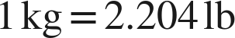. 5 kg to pounds.
11.02 lb

3. . 12 gal to liters.
45.42 L

4. . 50 L to gallons.
13.2 gal

For questions 5 through 7, say how many times the ratio is used.
5. 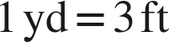. 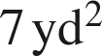 to square feet.
63 ft²
7 × 9: twice.

6.  and . 40 fl oz to liters.
1.2 L
5 c × 0.24.

7. . 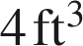 to cubic inches.
6,912 in³
4 × 1,728: three times.

Choose one.
8. . A floor is 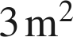 in area. How many square centimeters is that?
○ A. 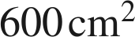
○ B. 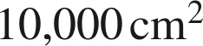
○ C. 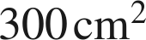
● D. 
D
3 × 10,000.

